Wyatt Duberstein

SE 317

06-14-2022

**Question 1:**

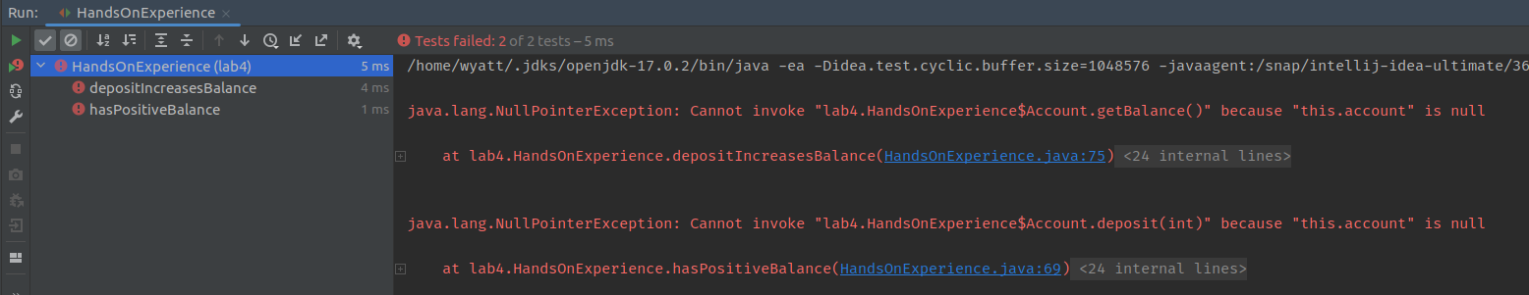Neither of the tests pass. This is because “this.account” is null. The object is literally declared freshly created like 5 lines before the start of the tests. This means that it hasn’t been declared as a specific object in memory and doesn’t have a balance to add any money to.

**Question 2:**

Yes, the two test cases now pass. This is because the account object has been initialized and exists in memory, so the two test cases can now update the account object meaning there is no errors that throw anymore.

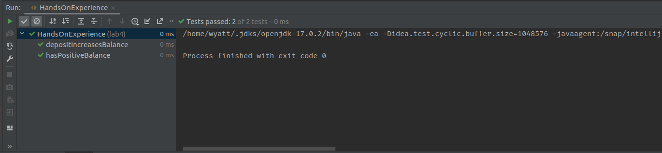

**Question 3:**

Yes, the test does pass. This is because it simply adds 50 to the balance, and then checks that the total balance is 50. The account comment doesn’t mean anything because it’s just a string and isn’t compared to either the balance of the account or the expected balance of the account. It says 100, but the test still passes.

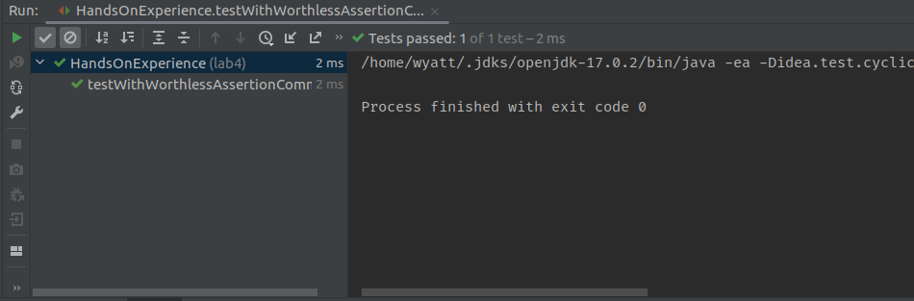

**Question 4:**

This is a test for the withdraw method. I made it so that you can withdraw a negative amount from the bank account, which means that the amount being withdrawn shouldn’t be negative and should be updated to a positive amount to avoid fraudulent transactions. This means that it should expect a decreased amount but receives an increased amount in the account.

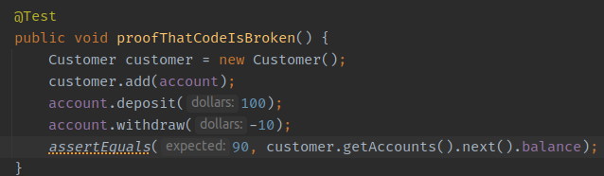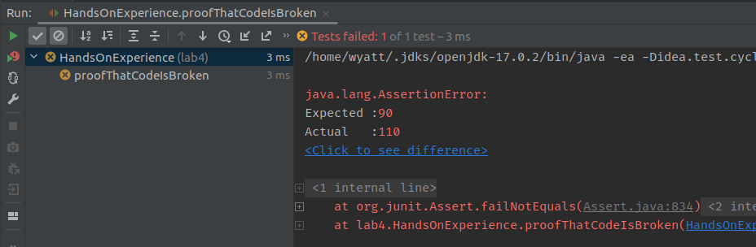

**Question 5:**

With the exception specified:

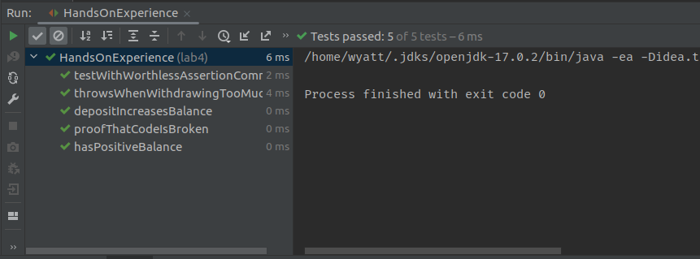

Without the exception specified:

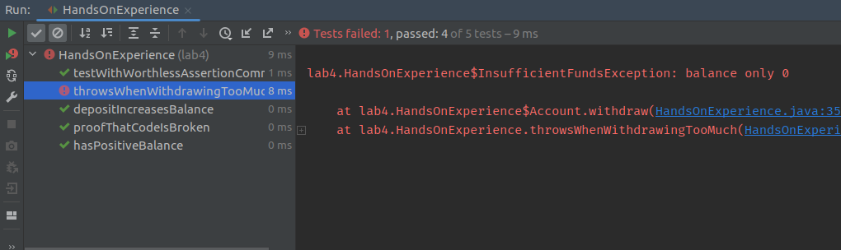

The reason it passes WITH the exception specified is because I am telling the method to expect a InsufficientFundsException to be thrown, meaning that when it is thrown, then the test passes.

When I remove the exception, the test fails because it is not being told to expect the exception to be thrown. When it is thrown, then the test can’t even finish properly.